<AKIProPlus>

Version <1.0>

Revision History

|  |  |  |  |
| --- | --- | --- | --- |
| **Date** | **Version** | **Description** | **Author** |
| 14/Setember/2014 |  | Fill out the introduction and product overview |  |
| 2/October/2014 |  | Fill out the project organization and management process. |  |
| 2/October 2014 |  | Develop the Gantt Chart |  |
| 19/Novemeber 2014 |  |  |  |

Table of Contents

Table of Contents

1. Introduction 4

1.1Purpose 4

1.2Scope 4

1.3Definitions, Acronyms, and Abbreviations 4

1.4References 4

1.5Overview 4

2. Project Overview 6

2.1Project Purpose, Scope, and Objectives 6

2.2Assumptions and Constraints 6

2.3Project Deliverables 6

2.4Evolution of the Software Development Plan 7

3. Project Organization 7

3.1Organizational Structure 7

3.2External Interfaces 7

3.3Roles and Responsibilities 8

4. Management Process 8

4.1Project Estimates 8

4.2Project Plan 8

4.2.1 Phase Plan 9

4.2.2 Iteration Objectives 9

4.2.3 Releases 10

4.2.4 Project Schedule 10

4.2.5 Project Resourcing 10

4.3Project Monitoring and Control 11

5. Annexes 12

# 

# Introduction

## Purpose

The purpose of this Software Development Plan is to act as a written-detailed guide to all stakeholders, describing all the necessary tasks in the development of the project. The plan serves as a “road-map” to achieve all goals and objectives of the project by identifying individual and group responsibilities and instruction on how each aspect of the plan should be carried out.

## Scope

This *Software Development Plan* describes the holistic plan to be used by the AkiProPlus project. The details of the individual tasks will be described in each deliverable plan. The document is divided into several parts each representing a different aspect required to develop the project. The project overview gives an overview of the project highlighting the objectives, assumptions constraints and the deliverables that will be produced. In addition this documents describes the organization of the project detailing the structure, external interfaces and provides details of the roles and responsibility of each member involved its development. Finally this document emphasizes the management process, which describes how the project will be managed including scheduling, budgeting and risk analysis.

## Definitions, Acronyms, and Abbreviations

DFD- Dataflow Diagram

ERD- Entity Relationship Diagram

## References

Course HomePage(URL): <http://myelearning.sta.uwi.edu/course/view.php?id=25738>

## Overview

This project plan document is needed to give a holistic plan in developing this new application. It includes the following information:

1. Project Overview: This details the purpose of the project and scope of the project. This identifies the objectives of the projects and highlights the assumptions and constraints associated with the development of the plan. In addition it provides the deliverables expected to be delivered. Finally it states how the project plan will adapt to the growth of the software development.
2. Project Organization: This describes the organizational structure of the project. It list all the members that will be associated in developing the application and give details of the roles and responsibilities of each member. External interfaces that will interact with the application will be highlighted in this area of the documents.
3. Management Process — explains the estimated schedule for achieving all milestones in the project, describes the deliverables. It describes how all tasks will be allocated to group members. In addition it describes how the project will be monitored. This includes all budget, schedule and quality controls that will be used and pinpoints how the project plan will be measured and reported. Identifying and mitigating risks is also another area that will be defined in this section.

# Project Overview

## Project Purpose, Scope, and Objectives

Zephrin’s Bakery Inc. is a family-owned bakery business, which supplies bread and pastries to the entire island of Barbados for the past 40 years. They currently employ 120 employees and cater to over 600 customers. Prior to the year 2000 all work was done manually using a pen and paper system. Consequently with the increased volume of data, this created much inefficiency in the company therefore paving the way for the introduction of a new system. Thus in the year 2000 the owner Andre Zephrin contracted Wayne Goodridge to design an application “Aki” to handle the basic running of the business. As time progressed this too became unsuited for the growth of the business and as a result AkiPro was designed and implemented by the year 2012. To give itself a competitive edge over its competitors namely Purity Bakery, the company wants to introduce a more automated and integrated system by incorporating all entities (personals) of the system. This scope of this project includes rewriting the old application into a web-based system and implementing additional features such as customer, merchandizer and delivery app.

The main objectives of this project:

* The current system will be re-written into a new system that will be interoperable with different platforms namely web, tablets and mobile so as to facilitate better communication among the different components and to avoid restriction to a physical location.
* Additional modules will be implemented into the system so as to create a more integrated, cohesive and reliable system including all entities of the business. These include:

1. A customer app will be implemented so that customers can gain direct access to the system thus being able to perform task at their own convenience in a localized area.
2. The delivery app will be implemented to co-ordination the daily transactions of all delivery personnel’s with the databases in the system and such makes the system more cohesive.
3. A salesperson app will be created to allow merchandisers to gain access to the system and perform necessary tasks.

## Assumptions and Constraints

The assumptions of the project include:

* The team comprise of four team members
* All necessary software tools will be available for use when required.
* All necessary hardware equipment will be available for use when required.
* The necessary funds will be approved.

The constraints of the projects are:

* The expertise of the team members since the productivity of the projects depends upon the skill of the team member and determines if outside expertise or training is required.
* The amount of work required in developing the project in relation to the number of available employees since if there is much more work to be done than members the workload for each member may be significant.
* Unexpected problems may occur that may hinder the project and cause delay in the delivery of the product.
* The time in which the new system to be delivered can affect the quality and scope of product.

## Project Deliverables

1. Preliminary Project Plan 03.10.2014

2. Requirements Specification 17.10.2014

3. Evaluation Report 31.10.2014

## Evolution of the Software Development Plan

The *Software Development Plan* will be revised as the project evolves. This includes:

* As more objectives/requirements are known the project plan will be updated accordingly
* The schedule will be updated as necessary to cater for any delay or advancements.
* As the project progresses team leaders will assigned team members accordingly to any new tasks.

# Project Organization

## Organizational Structure

Team Members:

* Sharifa Barrow
* Eka Douglas
* Donique John
* Richard Samuel

Each deliverable will be assigned a team leader(s) who is responsible for the co-ordination of all activities required to produce the deliverable. This includes the necessary allocation of employees and scheduling for producing that deliverable.

|  |  |  |
| --- | --- | --- |
| **Week** | **Deliverables** | **Team Leader(s) for the Deliverable** |
| 5 | Preliminary Project Plan | Sharifa Barrow |
| 7 | Requirement Specification | Eka Douglas  Donqiue John |
| 9 | Evaluation Report | Richard Samuel |

Table 1: This table shows the team leader in control of each deliverables

## External Interfaces

This project should interact with the following external groups:

* Customers: there are two main types of customer; the walk-in/ cash customers and the repeat/account customers, which can be further divided into weekly and monthly paying customers.
* Merchandisers: There are employees of the customer but are regarded as external entities. Their main interaction with the business is to go around to the different markets to analyze the products, make reports and can suggest any changes to the standing order from any customers.
* Suppliers: They have limited interaction with the application. However there main interaction with the application is to keep record of the purchase orders provided by them so they can be referenced for future purchases.
* Governments (tax suppliers): The application should interact with the government by producing reports, which the government will use to appropriately tax the company.
* Bank: The application should be able to generate reports as requested by the bank that may be used to conduct any future business.

## Roles and Responsibilities

For the team leader responsibility per phase, please refer to section 3.1. Ultimately the entire project team is responsible for the successful delivery of the product. The table below shows the activity to be done to produce each of the deliverable.

For most deliverables all members will collaborate in the initial development of each deliverable so as to provide what should be included in each deliverable. Then the assigned team member as stipulated in the table below will be mainly responsible for producing the write up in an organized manner.

|  |  |  |
| --- | --- | --- |
| **Deliverables** | **Task** | **Team Member(s) Responsible** |
| Project Plan | Developing project plan | All team members |
| Requirements Specification | 1. User requirements 2. System requirements 3. Use Cases 4. DFDs  * Customer App * Merchandiser App * Delivery App * Order Processing  1. ERDS  * Customer App * Merchandiser App * Delivery App * Order Processing  1. Activity 2. Sequence Diagrams 3. Resource Diagrams 4. GUI  * Conceptualize overall design * Implemented design in required tool * Customer App * Merchandiser App * Delivery App * Order Processing | Sharifa Barrow  Eka Douglas  Donique John  Donique John  Eka Douglas  Sharifa Barrow  Richard Samuel  All team members  Donique John  Eka Douglas  Sharifa Barrow  Richard John  Eka Douglas, Donique John  Eka Douglas, Sharifa Barrow  Richard Samuel, Donique John  All team members  All teams members |
| Evaluation Report | * Create test cases * Actual testing * Produce written document | All team members |

# Management Process

## Project Estimates

The project is estimated to be delivered in fewer three months or approximately 72 days. Each deliverable is estimated to take on average 2-3 weeks to complete.

The estimated cost of the project is $259, 680 TTD. A breakdown of this cost is given below.

Weekdays:

5 hours a day at a rate of $120/ hour = $ 600.00 /day

52 days Total **= $ 31, 200.00**

Weekends:

15 hours a day at a rate of $150 = $2,250.00

20 weekend- days total **= $ 45,000.00**

**Total = $ 76, 200.00/ per person**

**Overall Total = $ 300,480.00**

However this estimate may be adjusted as the project progresses primarily after each deliverable. Any delay must result in an extension of the overall schedule and thus may result in an increased in the estimated cost.

## Project Plan

The table below shows the estimated schedule of the project.

|  |  |  |
| --- | --- | --- |
| **Deliverables** | **Task** | **Estimated Completed date** |
| Project Plan | Developing project plan | 2.10.2014 |
| Requirements Specification | 1. User requirements 2. System requirements 3. Use Cases 4. DFDs  * Customer App * Merchandiser App * Delivery App * Order Processing  1. ERDS  * Customer App * Merchandiser App * Delivery APP * Order processing App  1. Activity Diagrams 2. Sequence Diagrams 3. Resource Diagram 4. GUI  * Conceptualize overall design * Implemented design in required tool * Customer App * Delivery App * Merchandiser * Order Processing   Integrate the different components into a single document | 4.10.2014  8.10.2014  9.10.2014  13.10.2014  12.10.2014  14.10.2014  14.10.2014  15.10.2014  14.10.2014  16.10.2014  16.10.2014  19.10.2014  20.10.2014  21. 10.2014    22.10.2014  28.10.2014  30.11.2014  26.10.2014  31.10.2014  2.11.2014 |
| Evaluation Report | * Create test case * Actual testing * Produce written report | 6.11.2014  18.11.2014  22.11.2015 |

The primary resource for this project is the four team members. Additional some software applications are also required. These include

* Microsoft Word; to create the document in a well organized manner
* Microsoft Project: to create the Gantt Chart showing the allocation of time for each phase
* Microsoft Visio: to create DFDs, ERDs and Activity Diagrams
* Pencil: A program to simulate the graphical user interface
* GIT Hub: To record changes by group members.
* Laptop: each member has their laptop to complete task

### Phase Plan

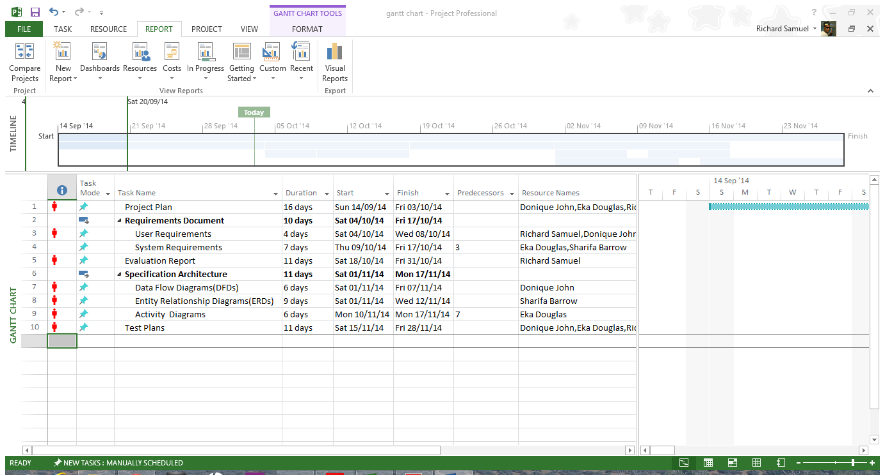

The major milestones are the different components of the deliverables , the completed deliverables and completion on the entire system. Please refer to section 2.3.

### Iteration Objectives

|  |  |  |
| --- | --- | --- |
| **Deliverables** | **Task** | **Objectives** |
| Project Plan | Developing project plan | * To give a holistic plan of the development of the project |
| Requirements Specification | 1. User requirements 2. System requirements 3. Use Cases 4. DFDs  * Customer App * Merchandiser App * Delivery App * Order Processing  1. ERDS 2. Activity Diagrams 3. Sequence Diagrams 4. Resource Diagrams 5. GUI  * Conceptualize overall design * Implemented design in required tool     Integrate the different components into a single document | * To state in natural language as well as to display diagrams of the services to be provided by the systems. * To define a detail description of the system functions and services * To describe the user requirements in amore technical detail to act as an input to users * To represent the flow of data throughout the system. They provide an overview of each module. * To describe the different aspect of the databases stored in the system. They give an overview of the relationship between the different files. * To outline the activities needed to perform each task * To show the sequence of steps of an activity * To show the different actions that can be carried out on a resource * To determine the color scheme and the overall format for the designs * To design the web, mobile and tablet GUI for the designated model |
| Evaluation Report | * Create test case * Perform actual testing and * Produce written evaluation report | * To come up with the testing scenarios to be test * To perform the actual tests and report finding * Produce the final document |

### Releases

### Project Schedule

Please refer to the scheduling table and the Gantt Cart diagram in 4.2 for the project schedule.

### Project Resourcing

The following training will be done

|  |  |
| --- | --- |
| **Training** | **Deadline for training** |
| GIT Hub training | 29.09.2014 |
| Website Protyping | 18.10.2014 |
| Training how to use Microsoft Visio | 1.11.2014 |
| Training on how to use pencil |  |
| Training to use DHC tool |  |

## Project Monitoring and Control

**Requirements Management**

The requirements for this system are captured in the Vision document. Requested changes to requirements are captured in Change Requests, and are approved as part of the Configuration Management process.

**Schedule and Budget Control**

The project manager maintains a schedule showing the expected date of each milestone. Checks-up are done every 3-7 days to ensure that each task in on schedule and to determine in the schedule is to be adjusted or if to assigned available team members to help with that task.

The budget will be also monitored so as to keep in the required range. If there is a change in budgeting to a given task.

**Quality Control**

Defects will be recorded as identified by the client or any team members and adjustments will be made.

All deliverables are required to go through the appropriate review process. The review is required to ensure that each deliverable is of acceptable quality, using guidelines given.

**Reporting and Measurement**

Updated schedule estimates will be generated at the end of each week.

**Configuration Management**

Appropriate tools will be selected which provide a database of all changes made by each user. E.g.: GIT hub.

Full backups are to perform for each file after any change has been made.

**Risk Management**

The risks will be identified in the project plan and will be evaluated at least once per task and documented in this table.

|  |  |  |  |
| --- | --- | --- | --- |
| Risk | Risk Ranking(High, Medium, Low) | Impact | Strategies/Contingencies Plan |
| Change in requirements as project progress. | High | This may increase the time to complete the project. | When gaining requirements from users, analysis can suggest requirements which might may be beneficial and as such maybe implemented earlier |
| File corruption/damage | High | This can cause a big extension to the schedule as the damaged/loss file will need to be recreated | Each file will be backed up on several mediums. |
| Security (hacking) especially on the web components | high | Hackers can gain information about personnel and financial information about the customers and company | Security measures will be put in place. |
| Technological change | Medium | It may be outdated for the latest version of different platforms | The project will be developed around the latest version of each platform. |
| Scheduling conflict between team member. | High | This may result in unwanted delays in the project | Using technology such as GIT will allows users to communicate without being in a local area |
| Unclear requirements | High | This may result in the product produced not what the user wanted. | Have regular interaction session with Dr. Wayne Goodridge to clarify requirements |
| Inability to meet deadlines | High |  | Other available employees may be assigned to help with task |

# Annexes